**New Zealand Screen Production Rebate**

**International Productions + Post, Digital & Visual Effects Rebate**

**Application for Final Certificate**

**1 November 2023 Criteria**

This application form should be read in conjunction with the [NZSPR Criteria for International Productions dated 1 November 2023](https://www.nzfilm.co.nz/resources/nzspr-criteria-international-productions) (the **Criteria**). Capitalised terms used in this application form have the definitions set out in Appendix 1 of the Criteria. By submitting this final application, you agree to be bound by the terms of the Criteria.

Applicants for an **Interim Rebate** should also use this form.

**Bundled productions:** a separate application form must be completed for each production within a bundle. (See clause 11 of the Criteria for more information on bundling.)

Applicants for the **5% Uplift** should use the Final application form for the 5% Uplift, **not** this application form.

By submitting this application, the applicant agrees:

* to be bound by the terms of the Criteria; and
* that the terms of the [NZFC Privacy Policy](https://www.nzfilm.co.nz/privacy-policy#:~:text=The%20NZFC%20and%20our%20third,unauthorised%20access%2C%20modification%20and%20disclosure.) will apply to all personal information submitted as part of its application.

If you have any questions about this form, please contact [nzspr@nzfilm.co.nz](mailto:nzspr@nzfilm.co.nz).

This application form has five sections:

* Section 1 – Applicant Information
* Section 2 – Production Information
* Section 3 – QNZPE
* Section 4 – Statutory Declaration
* Section 5 – List of Required Documents

Please complete all sections.

|  |  |
| --- | --- |
| **Submitting your application:** | **Attachments should be named and numbered as per the checklist in Section 5 of this form.**  Please send attachments as separate files (do not combine into one document).   * Email to [nzspr@nzfilm.co.nz](mailto:nzspr@nzfilm.co.nz) (if below 12MB); or * Send via file sharing link; or * Send via USB to:   Incentives Executive  New Zealand Film Commission  PO Box 11546, Wellington 6142 / Level 3, 119 Ghuznee Street, Wellington 6011 |
| **Please note:** | Once the NZFC has received all applicable documentation and has confirmed the application is complete, you will be sent a dated acknowledgement letter. The date of this letter is the start of the application process. |

**Confidentiality**

Information that you supply to the NZFC or an independent consultant may be provided to the Rebate Panel, Inland Revenue Department (IRD), Ministry of Business Innovation and Employment (MBIE), Ministry for Culture and Heritage (MCH) and other independent consultants where reasonably necessary during the application and approval process.

Once an International Rebate has been approved and paid, the NZFC or MBIE can publish or announce the following information:

* the names of successful applicants;
* the amount of the QNZPE incurred by each applicant; and
* the Rebate amount paid to each applicant.

The NZFC will use reasonable efforts to maintain the confidentiality of the information provided by you. The NZFC, Rebate Panel, IRD, MBIE and MCH are government entities, which are subject to various disclosure requirements, for example disclosure of information under the *Official Information Act 1982*. None of them will be liable for any disclosure it believes (acting reasonably) it is required to make.

You should clearly indicate those parts of the application that you regard as commercially sensitive and confidential. In processing a request under the *Official Information Act 1982*, the NZFC or relevant New Zealand Government department or agency will use best efforts to consult with you prior to a decision on release of the documents, but you should be aware that your designation of information as commercially sensitive or confidential will not automatically result in that information being withheld by the NZFC or other government department or agency.

Statistical information provided in this application may be used by New Zealand Government ministries, departments and agencies. These ministries, departments and agencies will usually comprise: the NZFC, MCH, IRD, MBIE and Employment and Statistics New Zealand.

|  |  |  |
| --- | --- | --- |
| Section 1 | Applicant Information | |
| Date of application:  Full name of applicant entity (Registered name):  Registration number:  Registered address:  Business/mailing address:  New Zealand GST Number (if any): | | |
| Contact person:  Role of contact person: | | Business phone:  Mobile phone:  Email: |
| The applicant must complete an online exit survey about their experience of making a screen production in New Zealand. This information be used for research and marketing purposes and, unless the applicant agrees otherwise, it will be treated confidentially, and only non-identifying or aggregated information will be made public.  The NZFC will not begin processing a Final application until the NZFC has received a complete exit survey. Please use the link below to complete the survey:  [**New Zealand Screen Production Rebate – International Exit Survey**](https://www.research.net/s/screen-grant)  *Not required for Interim applications.* | | |

|  |
| --- |
| **1.1 Registration** |
| Did the applicant register the production and receive acknowledgement from the NZFC in respect of that registration in accordance with clause 26 of the Criteria?  **YES  NO**  If NO, the production is **not eligible** for an International Rebate. |

|  |
| --- |
| **1.2 Special Purpose Vehicle** |
| Is the applicant a special purpose vehicle established principally in relation to making the production?  **YES**  **NO**  If NO, please indicate which exception under clause 12.2 of the Criteria applies:   1. Series 2. Repurposing 3. Bundling 4. PDV Rebate Exception   Please note that an applicant must have its own GST and payroll registration numbers and its own bank account. The applicant’s GST and payroll returns must not be grouped with any other entity for tax purposes. If you are relying on the PDV Grant Exception, then you must have obtained a waiver of the special purpose vehicle requirement from the NZFC in accordance with clause 12.2(d) of the Criteria. |

|  |  |  |  |
| --- | --- | --- | --- |
| **1.3 Residency Status** | | | |
| 1. Complete the following in relation to the **Special Purpose Vehicle** (SPV) | | | |
| **Names of directors or partners** | **Citizenship of directors or partners** | **Country of permanent residence** | **Address of directors or partners** |
|  |  |  |  |
|  |  |  |  |
|  |  |  |  |
|  |  |  |  |
| 1. Complete the following in relation to the **SPV’s parent company** (or companies) | | | |
| **Names of shareholders or general partners** | **Citizenship of shareholders or country of incorporation (if a company)** | **Country of permanent residence** | **% beneficial interest in the company or partnership** |
|  |  |  |  |
|  |  |  |  |
|  |  |  |  |
|  |  |  |  |
| You must supply Company Extracts (from the [New Zealand Companies Register](https://companies-register.companiesoffice.govt.nz/)) with your application. | | | |

|  |
| --- |
| **1.4 Responsible Entity** |
| Was the applicant the entity responsible for all activities involved in making the production in New Zealand or, for the PDV Grant, all PDV Activity on the production in New Zealand?  **YES**  **NO**  If NO, please provide details: |
| Has the applicant taken over responsibility for making the screen production (or undertaking the PDV work) from another production entity?  **YES**  **NO**  If YES, the previous entity (or entities) should be listed below with the relevant legal agreement confirming the transfer of responsibility also included as an **attachment.** |
| Registered name:  Registered address:  Registration number:  **Note**: The audited expenditure statement must indicate which amounts relate to expenditure of a previous company (or companies). |

|  |  |
| --- | --- |
| Section 2 | **Production Information** |
| Title of Production:  ***Working Title(s) - if applicable:*** | |
| Synopsis Provide a brief synopsis of the production:  **Note:** If the production has NOT been released to the public or international marketing for its imminent release has not occurred, the NZFC may require a copy of the screen production or a dated selection of footage. | |

|  |
| --- |
| **2.1 Format** |
| **Feature film (theatrical release)**  *NB: if you are shooting more than one film simultaneously or concurrently, please see clause 8.3 of the Criteria.*  **Television or other non-feature film (please specify below)**  *NB: if you are shooting more than one film simultaneously or concurrently, please see clause 9.3 of the Criteria.*  Television drama (single episode)  Television documentary/factual/reality (single episode)  Television drama (series)  Television documentary/factual/reality (series)  Other (please describe):  On what platform will it be first released? |
| **Length of Production**  What is the total running length of the completed production (in minutes)?  If a series, what is the total number of episodes? |
| **Excluded Formats**  Does the production fit into one of the following categories?   * an advertising programme or commercial * a discussion programme, current affairs programme, news, a panel programme or a programme of a like nature * pornography * a training programme * an interactive digital game (other than transmedia content as per clause 17.3(b)(iv) of the Criteria) * a production of a public event, including a sports event * for television or other non-feature film productions only, a programme principally made for the New Zealand market   **YES  NO**  **Note:** If YES, the production is not eligible for an International Rebate. |
| **Production Dates**  Date of first day of official pre-production:  Date of commencement of Principal Photography in New Zealand:  Date of commencement of Principal Photography overseas:  Date of completion of Principal Photography:  *If you are applying as a PDV Production, please also complete the following:*  Date of commencement of PDV Activity in New Zealand:  Date of completion of PDV Activity in New Zealand:  Date of Completion of production (if not yet completed, then insert estimated date of Completion):  **Note:** Completion is defined in Appendix 1 of the Criteria. You must submit your **Final** application within **six-months** after this date. Late Final applications may not be accepted. |
| **QNZPE Dates**  Date the applicant first incurred QNZPE:  *(this is the not the date of any prior development expenditure incurred by another entity)*  Date of completion of QNZPE: |

|  |
| --- |
| **2.2 Qualifying New Zealand Production Expenditure (QNZPE) Threshold** |
| $15 million or more (for a feature film released theatrically)  $4 million or more (for a television or other non-feature film production)  Interim application - $50 million or more  PDV Rebate - $250,000 or more  Bundled production – please provide details:  *QNZPE for this production:*  *Format (feature/series/telefeature/pilot):*  *Title(s) of other production(s) in the bundle:* |

|  |  |
| --- | --- |
| **2.3 Category of production (PDV or Live Action)** | |
| Does the production Include QNZPE relating to filming with real people or animals?  Is expenditure on Visual Effects Production no more than 55% of QNZPE?  **Note:** If the applicant answers YES to both questions, the production is a Live Action Production. If the applicant answers no to one or both questions, the production is a PDV Production. | **YES  NO**  **YES  NO** |

|  |  |
| --- | --- |
| **2.4 Other Rebates and New Zealand Incentives** | |
| Has the production received or applied for production funding from any New Zealand Government agency?  Has the production received or applied for the New Zealand Rebate, Large Budget Screen Production Grant or Screen Production Incentive Fund, or any tax incentives?  If the answer is YES to either, then the production is not eligible for an International Rebate. | **YES  NO**  **YES  NO** |
| Has the production incurred any costs that were paid more than ten years prior to the start of Principal Photography or PDV Activity (historical costs)?  If YES, then please specify what costs:  **Note**: Historical costs cannot be claimed as QNZPE unless the Rebate Panel approves such costs. Refer to clause 6 of the Criteria for other excluded historical costs. | **YES  NO** |

|  |
| --- |
| **2.6 Credit and Promotional Materials** |
| Please note that the applicant must provide in the completed production, an on-screen end credit and an on-screen NZFC logo. The applicant must also provide promotional materials to the NZFC in accordance with the [Promotional Materials Schedule](https://www.nzfilm.co.nz/resources/promotional-materials-schedule) on the NZFC website.  The current NZFC logo can be obtained by contacting [nzspr@nzfilm.co.nz](mailto:nzspr@nzfilm.co.nz). **Please note, unless otherwise agreed with the NZFC, the logo should only be used in conjunction with the end credit text:**  *The filmmakers acknowledge the assistance of the New Zealand Government’s Screen Production Rebate*  **Note:** The applicant must attach to a Final application, proof of compliance with the credit and logo requirements. This requirement can be met by attaching a screenshot that shows the credit and logo, or by supplying a copy of the production.  Promotional materials are not required with Interim applications.  The NZFC may wish to use promotional material from the production on the [NZFC website](https://www.nzfilm.co.nz/international/made-new-zealand). Please ensure any restrictions on the use of supplied materials, contact details for permissions, image credits, embargoes and other considerations are included with your application.  In exceptional circumstances, the NZFC may waive one, or both, of these requirements. If you wish to apply for a waiver of the credit and/or promotional materials requirements, please include a letter with your application outlining why you are unable to provide a credit and/or promotional materials. |

|  |
| --- |
| **2.7 Compliance with New Zealand Immigration Law** |
| Has the applicant, to the best of its knowledge, complied with all applicable New Zealand immigration laws relating to the employment of non-resident cast and crew who worked on the screen production?  **YES  NO**  If NO, please provide details: |

|  |  |
| --- | --- |
| **Section 3** | **QNZPE** |
| **GST:** The International Rebate is calculated in relation to amounts that are net of New Zealand Goods and Services Tax (GST). Therefore, all figures in this application should be quoted net of GST.  **Non-accrual basis of expenditure:** To be QNZPE, an expenditure item must have actually been incurred and paid by the applicant on the making of the production prior to the date the final application is submitted. | |

|  |  |
| --- | --- |
| **3.1 QNZPE** | |
| Total Expenditure | NZ$ |
| QNZPE | NZ$ |
| Expenditure on Above The Line Costs | NZ$ |
| Expenditure on Above The Line Costs as a percentage of QNZPE | % |
| All costs claimed as QNZPE must be presented in an audited expenditure statement. Please use the expenditure statement template available [here](https://www.nzfilm.co.nz/resources/expenditure-statement-template-nzspg-international) or email [nzspr@nzfilm.co.nz](mailto:nzspr@nzfilm.co.nz) to request a copy. An example is shown at the end of this section. **All expenditure must be identified in New Zealand dollars**. All expenditure incurred and paid in a foreign currency must be converted into New Zealand dollars on a monthly basis at the mid-month exchange rate published on the [IRD website](https://www.ird.govt.nz/business-income-tax/overseas-currency-convert-nz.html) for the month in which the payment was made.  The expenditure statement must include details of:   * Total expenditure * Non-QNZPE * QNZPE   **To ensure you meet the requirements of clause 17.4(o) of the Criteria, you must also provide a breakdown of your calculation of Above The Line Costs**. This breakdown must include a short description of each of the goods and services included in your calculation of Above The Line Costs. | |

|  |  |
| --- | --- |
| **3.2 Goods sourced from overseas** | |
| Please identify all goods sourced from overseas that you intend to claim as QNZPE **and** explain why the goods meet the requirements of clause 17.2(b) of the Criteria.  **Note:** you must attach to this application, evidence supporting your explanation for each good/category of goods. | |
| **Name of good or category of goods** | **Explanation** |
|  |  |
|  |  |
|  |  |
|  |  |

|  |
| --- |
| **3.3 General Ledger** |
| The general ledger for the production must be provided and must, at a minimum, include the following details in relation to each cost:   * date * description * amount of expenditure * details of each service provider/vendor * whether such expenditure is QNZPE or non-QNZPE * when the good or service or land was used in the making of the production * whether the expenditure is payroll, petty cash, accounts payable or a journal * date when, or period of time over which, the item was used on the production   A final production cost report and a balance sheet (a trial balance is acceptable if a final is not available) must also be included with your Final application. **These documents must match the GL and audited expenditure statement**.  An example of a general ledger excerpt is shown at the end of this section and can be downloaded as a template [here](https://www.nzfilm.co.nz/resources/general-ledger-template-nzspg-nz). NZSPR required free fields are indicated in yellow. |

|  |
| --- |
| **3.4 Audit** |
| Please fill in the contact details for your auditor below. |
| Name of auditor: |
| Company name: |
| Qualifications: |
| Telephone: |
| Email: |

|  |
| --- |
| **3.5 Currency Exchange** |
| All expenditure incurred in foreign currencies must be converted into New Zealand dollars at the mid-month exchange rate published on the [IRD website](https://www.ird.govt.nz/business-income-tax/overseas-currency-convert-nz.html). If the exchange rate is not known, the IRD’s average monthly exchange rates may be used. A schedule of all QNZPE in foreign currencies should be provided. |

|  |
| --- |
| **3.6 Non-Arm’s Length Expenditure** |
| **Please complete the Non-Arm’s Length Expenditure template available** [**here**](https://www.nzfilm.co.nz/resources/nzspg-template-non-arms-length-expenditure) **or email** [**nzspr@nzfilm.co.nz**](mailto:nzspr@nzfilm.co.nz) **to request a copy.** An example is shown at the end of this section.  Please provide the name of all entities or persons (as identified in the expenditure statement) who provided goods, services or land in making the production and who are associated with the applicant or any of its associated entities. You must also include with your application, supporting documentation such as contracts, contract variations, timesheets, invoices and/or other agreements for all non-arm’s length expenditure claimed as QNZPE.  Refer to clause 21 of the Criteria for more information about the Rebate Panel’s assessment of non-arm’s length expenditure. |

|  |
| --- |
| **3.7 Assets** |
| Did the applicant acquire any assets for use on the production in New Zealand?  **YES**  **NO**  If YES, please either:   1. attach a schedule of depreciation in relation to those assets; or 2. if no assets have been retained at the date of this application, please attach a schedule providing information on the disposal of those assets, including date of sale and sale price. |

|  |
| --- |
| **3.8 Major Supplier** |
| Does 75% or more of the QNZPE claimed in this application relate to goods or services provided by the same supplier/vendor?  **YES**  **NO**  If YES, please attach a copy of the supplier/vendor agreement and copies of all invoices issued to the applicant by that supplier/vendor. |

Click [here](https://www.nzfilm.co.nz/resources/expenditure-statement-template-nzspg-international) to download this template or contact [nzspr@nzfilm.co.nz](mailto:nzspr@nzfilm.co.nz) to request a copy.



Click [here](https://www.nzfilm.co.nz/resources/general-ledger-template-nzspg-nz) to download this example or email [nzspr@nzfilm.co.nz](mailto:nzspr@nzfilm.co.nz) to request a copy.

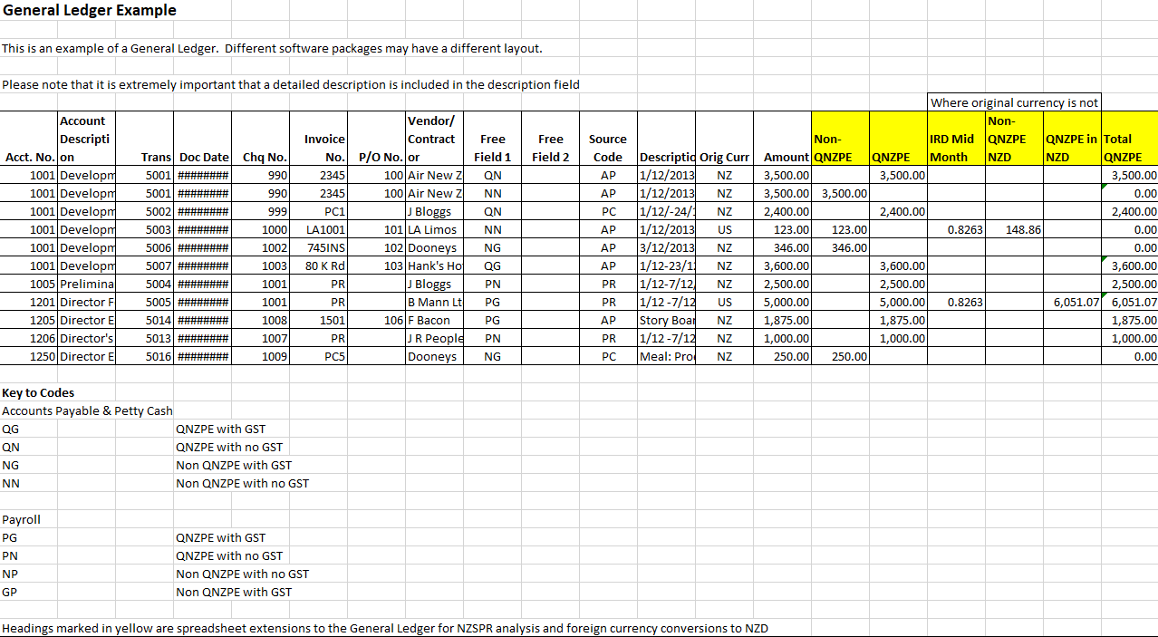

Click [here](https://www.nzfilm.co.nz/resources/nzspg-template-non-arms-length-expenditure) to download this template or contact [nzspr@nzfilm.co.nz](mailto:nzspr@nzfilm.co.nz) to request a copy.

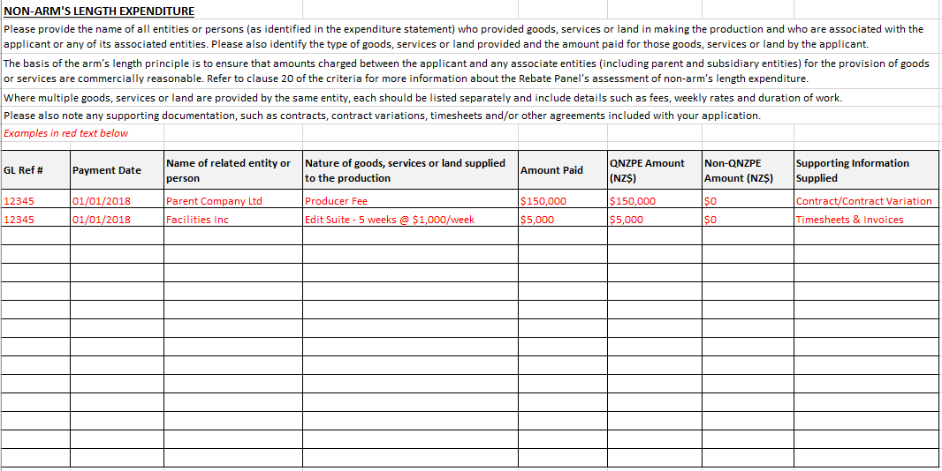

|  |  |
| --- | --- |
| Section 4 | Statutory Declaration |

**The applicant must complete the Statutory Declaration below to accompany this application certifying that the content of the application is true and correct. This should be completed by an officer of the applicant or a person authorised by the applicant in writing to do so.**

I, (1)  , of (2)

do solemnly and sincerely declare on behalf of (3)

that the information contained in this application for the New Zealand Screen Production Rebate, and the documents attached to it, are correct and true in every particular and I make this solemn declaration conscientiously believing the same to be true and by virtue of the New Zealand Oaths and Declarations Act 1957.

(4)

Declared at

This  day of

Before me,   
 (5)

(6)

1. Here insert name of person making the declaration. This person should be authorised to make the declaration on behalf of the applicant company.
2. Here insert address and office held in the applicant of person making the declaration.
3. Name of applicant.
4. Signature of person making the declaration.
5. Signature of person before whom the declaration is made.
6. Here insert name and title of person before whom the declaration is made. This must be a ‘prescribed person’ - Barrister and Solicitor of the High Court of New Zealand, Justice of the Peace, Notary Public, Member of Parliament, Registrar of the District Court. If the declaration is made outside New Zealand please refer to [section 11 of the *Oaths and Declarations Act 1957*](https://www.legislation.govt.nz/act/public/1957/0088/latest/DLM316109.html).

|  |  |
| --- | --- |
| **Section 5** | **List of Required Documents** |

**PREPARING YOUR APPLICATION:**

* Attachments should be named and numbered, as per this checklist.
* Please send attachments as separate files (do not combine into one PDF).
* All documents must be provided in **English.**
* Once the NZFC has received **all** applicable documentation listed above and has checked the application, you will be sent a dated acknowledgement letter, which indicates the start of the application process.

* All these documents should be as at the same date

|  |  |  |  |
| --- | --- | --- | --- |
|  |  | **Attached** | **N/A** |
| **Section 1 Documents (Applicant Information)** | | | |
|  | Completed application form including the statutory declaration. |  |  |
|  | Completed online exit survey ([NZSPR – International Exit Survey](https://www.research.net/r/screen-grant?sm=YWES5u73JpgySOteFXhzSo4FcAZFG%2bHHnHiRbtCY8AY%3d)). *Check ‘Attached’ once the online survey has been submitted. Not required for Interim applications.* |  |  |
|  | A Company Extract (from the [New Zealand Companies Register](https://companies-register.companiesoffice.govt.nz/)) dated within a week of the date of this application, or verification of a foreign corporation with a fixed establishment in New Zealand for tax purposes. |  |  |
|  | Fully executed Production Services Agreement or other document verifying the level of responsibility of the applicant for the making of the production in New Zealand, or for carrying out the PDV Activity in New Zealand. |  |  |
|  | Any agreement relating to the transfer of the production from a previous production entity or entities. |  |  |
| **Section 2 Documents (Production Information)** | | | |
|  | Schedule of key production dates. *Daily Progress Reports (DPRs) and call sheets to be provided upon request.* |  |  |
|  | Final one-line shooting schedule. |  |  |
|  | Proof of distribution or exhibition arrangements*. This can be in the form of a deal memo or letter of confirmation from the distributor or broadcaster on official letterhead.* |  |  |
|  | Proof of the required on-screen end credit and logo, as per clause 35. *Screenshot preferred. Not required with Interim applications.* |  |  |
|  | Final list of production credits. *A draft list is required with Interim applications.* |  |  |
|  | Final list of cast and crew showing role, permanent residency and citizenship of each person. |  |  |
| **Promotional material**(Please refer to the [Promotional Materials Schedule](https://www.nzfilm.co.nz/resources/promotional-materials-schedule) on the NZFC website for full details).  *Not required with Interim applications.* | | | |
|  | Publicity Stills: At least 12 high resolution publicity stills with captions and any required image credits (JPEG, TIFF or PNG preferred). *Half to include behind-the-scenes production activity emphasising New Zealand’s role in the production, and the other half featuring scenes from the completed film.* |  |  |
|  | One sheet artwork/posters including electronic copy (JPEG, TIFF or PNG preferred). |  |  |
|  | Trailer(s). |  |  |
|  | Press Kit (if one is produced). |  |  |
|  | Electronic Press Kit (EPK). *Note: Items not cleared for New Zealand promotional use may be removed.* |  |  |
|  | Schedule of any restrictions on the use of supplied promotional materials, including contact details for permissions, image credits, embargoes and other considerations. |  |  |
| **Section 3 Documents (QNZPE)** | | | |
|  | Expenditure statement in Excel (template available [here](https://www.nzfilm.co.nz/resources/expenditure-statement-template-nzspg-international) or contact [nzspr@nzfilm.co.nz](mailto:nzspr@nzfilm.co.nz) to request a copy - refer to the example in Section 3 for detail required).* |  |  |
|  | Auditor’s report (from an NZFC approved auditor) plus a copy of the audited expenditure statement signed or stamped by the auditor. |  |  |
|  | Breakdown of calculation of Above The Line Costs. |  |  |
|  | Supporting evidence for inclusion of overseas-sourced goods claimed as QNZPE. |  |  |
|  | Balance Sheet (a trial balance sheet is acceptable if the final is not available).* |  |  |
|  | General ledger of **audited** production expenditure in Excel (refer to the example in Section 3 for detail required).* |  |  |
|  | Final production cost report – pdf. |  |  |
|  | Final production budget (full) – pdf. |  |  |
|  | Schedule of non-arm’s length expenditure with relevant supporting documentation (template available [here](https://www.nzfilm.co.nz/resources/nzspg-template-non-arms-length-expenditure) or contact [nzspr@nzfilm.co.nz](mailto:nzspr@nzfilm.co.nz) to request a copy). |  |  |
|  | Asset register. |  |  |
|  | Major supplier/vendor agreement and copies of all invoices issued to the applicant by that supplier/vendor. |  |  |
|  | Schedule of foreign currency expenditure claimed as QNZPE converted at appropriate exchange rate. |  |  |
|  | Fully executed Above-The-Line cast contracts. *Generally understood in the industry as ‘star(s)’/ core cast members within an ensemble cast.* |  |  |
|  | Fully executed Above-The-Line crew contracts. *Generally understood in the industry as Executive Producer(s), Producer(s), Director(s) and Writer(s).* |  |  |
|  | Cast and crew travel schedule showing all arrival and departure dates from New Zealand and nationality of person travelling (template available [here](https://www.nzfilm.co.nz/resources/template-travel-schedule) or contact [nzspr@nzfilm.co.nz](mailto:nzspr@nzfilm.co.nz) to request a copy). |  |  |
|  | Schedule of all payments made to non-resident cast and crew showing portion claimed as QNZPE. |  |  |
|  | Schedule of any non-recoverable advances paid to any cast or crew member (where all or part of that person’s fee is claimed as QNZPE). |  |  |
| **IRD requirements** | | | |
|  | Schedule of payments to non-resident contractors where non-resident contractors withholding tax has not been deducted because a certificate of exemption was issued, or they qualified under the 92-day *de minimus* rule. |  |  |
|  | Schedule of GST exempt or zero-rated expenditure which has been claimed as QNZPE (e.g., air travel into New Zealand). |  |  |
|  | Schedule of GST expenditure which is NOT claimed as QNZPE. |  |  |
|  | Schedule of payments for non-resident equipment rentals which have NRCWT deducted from the payment, or a special tax rate certificate (‘STRC’) is held, where a specified rate has been deducted. |  |  |